Meta Description:
Want to build a strategic lead generation plan for your business? Learn about Lead Nurturing, common challenges & their solutions, and essential lead tools.

How to Build a Strategic Lead Generation Plan?
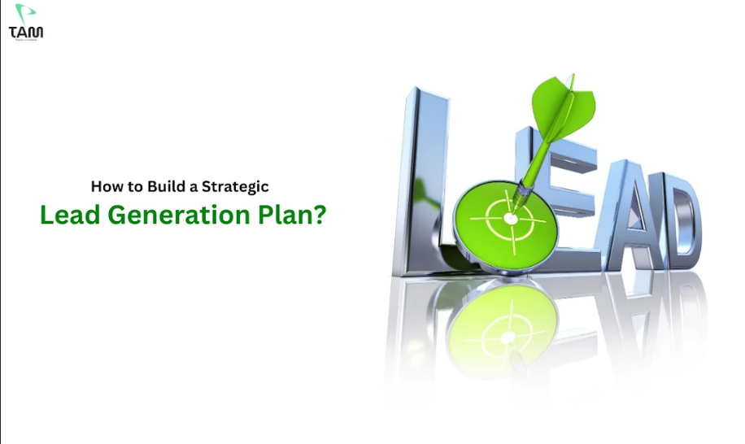
Lead generation is all about finding or generating more qualified leads through sales and marketing tactics. This way, you are basically creating a potential pool of qualified prospects through the sales funnel.
Lead generation is an essential part of digital marketing strategies in Dubai that allows brands to assess their prospects and craft effective strategies for target audiences.
Every brand follows a different digital marketing approach totally depending on the market it serves and the target audience it is interested in. In order to create an effective lead generation plan, there are some rules you need to follow while creating this plan.
Here, we will discuss in detail everything related to the lead generation plan.
You know what, you don’t have to be a specialist to make an effective plan. What you need is just this guide and proper lead-generation tools to make this happen.

How to Build a Strategic Lead Generation Plan?
There are several strategies that are involved in establishing a strategic plan for lead generation.
Read this to get directions on how to come up with a reliable plan depending on your business requirements.
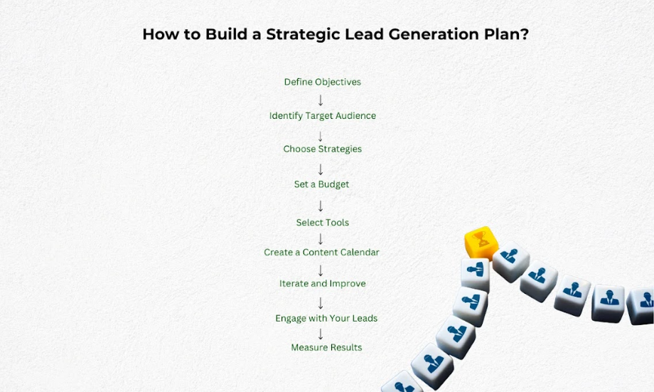

Define Objectives:
This should begin with the development of a very clear understanding of the examinee’s needs and objectives. Set specific, measurable goals. For instance, you can set the target of securing a specific number of sales leads per month, whereby they strive to acquire one hundred genuine sales leads.
A vision statement related to your strategies can be used to determine whether your plans are accomplishing the intended goals.

Identify Target Audience:
Conduct research and prepare a document about the definition of the ideal customer. Always analyze yourselves targeting their attributes such as age, gender, purchasing habits, etc.
It will be important when working in Dubai to take into account cultural differences and inclinations. Here are some factors you can consider related to the profile of your target audience:

B2B:
In the B2B sector, here are some factors you can consider while identifying your target audience:
- Industry
- Growth trends in the industry
- Customer size
- Customer type (B2B, B2C)
- Location
- Revenue
- Ownership of the company
- Job title of the person contacted
- Company size

B2C:
In the B2B sector, consider the following factors before making any decision:
- Yearly income
- Age
- Location
- Marital status
- Education level
- Gender

Choose Strategies:

Inbound, outbound, or hybrid, this is a question you will need to answer before adopting the strategy.
Inbound is a process that attracts the attention of customers through consumption and interaction.
Outbound is more targeted and active in nature where the selling efforts involve approaching the prospects in a direct manner such as through cold calls or cold emails.
Therefore, make your decision based on your business objectives and available resources.

Set a Budget
Due to the fact that leads can be generated in ways other than advertising, you should allocate resources for different tactics appropriately.
Make sure you define the amount of money that you are willing to spend on advertising, suitable tools, and manpower.
Budgeting is important because it helps any individual plan how much he or she should spend in order to realize the best returns on investment.

Select Tools
It is possible to identify which tools will be helpful in your case.
A number of technologies involved with the contemporary management of deals include CRM systems, sales, and marketing automation, as well as analytics platforms.
It’s advisable to have tools that will suit the goal of the research and the amount of money that is available to fund the process.

Create a Content Calendar
Schedule content release and promotion campaigns.
This gives a structure to the marketing activities and also enables the right message to be shared with the target market at the right time.
This involves the writing of blogs, and articles, the use of social media, and creating and sending emails to clients.

Iterate and Improve
This shows that it is good to always evaluate and optimize your strategies.
The first approach can be analyzed and understood as a strategy that is more effective than the second one, which failed and never even began.
This is especially the case particularly when it comes to changes that are taking place in Dubai’s economy, which can be highly volatile.
Make analytical adjustments from the data acquired in order to make sound decisions.

Engage with Your Leads
Enumerate all engaging steps to keep in touch with the leads and how to cultivate them.
It is important for the individuals to be engaged so as to turn the leads into customers.
Engaging with the leads can be through sending individual photographs, emails, social media interactions, and follow-up calls.

Measure Results
Ensure that you come up with a set of measures for evaluating the impact of your plan.
First, the goals of the funnel can be measured by a range of parameters, including conversion rates, quality of leads, and ROI.
The proposal of a schedule enables you to determine the right course of action as well as enshrine an ideal condition that can be scored.
Measurement is a plus for any activity.

How Can You Convert a Lead into a Paying Customer? (Lead Nurturing)
The process of turning a lead into an actual customer entails a technique known as lead nurturing.
Here is a simple guide on how you can effectively use this technique:

Understand the Buyer’s Journey:
Be flexible depending on where the lead is in their funnel. Work more and collaborate with others.
Understand that each lead is in a different stage from the staged model, awareness stage, consideration stage, and decision stage.
Customize your messages accordingly.

Personalize Communication:
Although the current technology has made communication easier, it is still best to make use of highly personalized techniques that can relate to the target group adequately.
When addressing a specific person, it is better to mention their name and, if possible, refer to any conversations you previously had.
By personalization, relevance is achieved and better relationships are built.

Provide Value:
Give advice and information that pertains to the lead’s worries.
In Dubai, where the business sense is on the roof, offer them something that they will find informative and useful such as an industry report or a webinar. By demonstrating expertise, you can build trust.

Follow Up Promptly:
Maintain engagement through timely follow-ups.
A fast response generally indicates alertness and can be a highly valuable means for increasing the rate of conversion.
Timely communication is important. Indeed, the best way to use these techniques is through automating them.

Use Marketing Automation:
The fifth recommendation is to leverage tools that can be used to automate nurturing processes.
Some of the abilities of marketing automation platforms include sending emails on a schedule, tracking interactions, and identification of the audience.
Lead nurturing is a process that must be well approached and managed by automation in order to maintain coherence and efficiency.

Address Objections:
The target audiences also have certain potentially conflicting issues, objections, and concerns, which should be addressed when presenting your proposal.
Leads are likely to have some concerns when confronted with your proposal, so it is good to counter these loopholes before they arise.
Providing solutions satisfies the leads and leads them to a level of making the purchase.

Utilize Testimonials:
Use more success stories, and testimonial forms of advertisement as they help to create trust.
In the case of Dubai where reputation is paramount, getting feedback from other clients who have benefited from the specific service can go a long way in penetrating the market.

Offer Unique Incentives:
Use incentives such as offering discounts or bonuses in order to ensure that you provide your leads value for money.
This will depend on some incentives that will make such a lead turn into a paying customer.
Make sure the incentives you offer correspond with your brand and deliver maximum worth.

Request Feedback:
You should use feedback to check and enhance your action plan and working approach. During a sale, the last thing customers should be asked is their opinion about the sale or service just provided.
Feedback also offers valuable information about the effectiveness of some techniques and direction to improve in others, when it comes to lead nurturing.

What Are the Common Challenges in Lead Generation, and How Can They Be Overcome?

5 Common Challenges in Lead Generation and Their Solution:
The process of lead generation in the Middle East especially in Dubai, UAE poses certain peculiarities.
To ensure that any of these challenges are met, it is important to understand them first to come up with ways of addressing them.
Let us present five typical problems that are found in businesses:
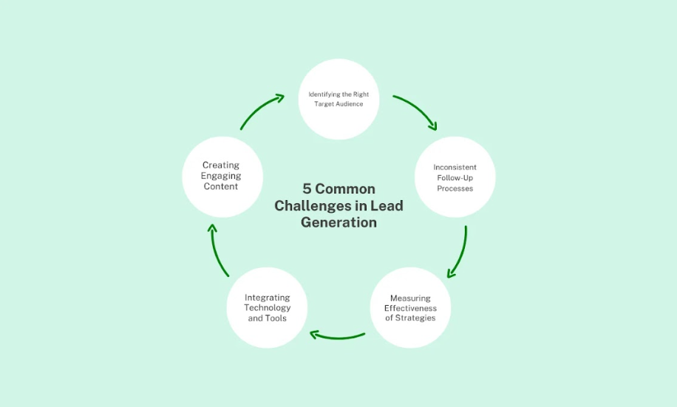

1. Identifying the Right Target Audience
One of the greatest difficulties is to identify the target market upon which the entire strategy will be based.
The issue with the demographic that corresponds to this aspect is that it is really hard to clearly define who exactly is the target market of a business that is operating in Dubai.
It is very unwise to take an incorrect perception of the target group since this may lead to the misuse of time, energy, money, and even materials in the campaigns.

Solution:
Conduct thorough market research. Gather relevant data, and be acquainted with your audience’s demography, psychography, and ethnography.
Make sure you create consistent buyer personas to orient your marketing campaign. This will determine the kind of campaigns to be conducted so that you can attract the best market, ultimately enhancing the chances of attracting quality leads.

2. Creating Engaging Content
People always stay engaged with the content that is quite engaging to them by ensuring that the following aspects are met.
Nevertheless, it is not easy to come up with content that will be relevant to the attention of the target market.
Since creating corporate content, businesses are always divided between what is informative and what is interesting.

Solution:
The best way to combat such a problem would be to put more effort into providing good and topical content.
Always provide a real-life example to support what you are saying or writing to make it easy to comprehend and memorable to the consumers.
Focus more on content like Blog posts, videos, and Infographics. Ensure that your content is newly posted so that the visitors will find it interesting and unique.

3. Inconsistent Follow-Up Processes
It is always essential to contact potential clients after identifying them to capture them to your business side.
On the other hand, a lack of proper follow-ups will decrease your chances of acquiring potential leads.
Research revealed that if contact follow-up is not done properly, potential leads can easily be lost and not be followed on properly.

Solution:
Create a follow-up plan that is organized. However, where practical and if applicable, use activated CRM tools to follow up and make certain all retrial executions are consistent. Treat it with subjectivity to ensure it has a better influence on its target.
Develop routines that would reduce the chances of following any particular lead to extremes so that no lead is left untouched.
This will go a long way to building up the relationship, along with standard follow-up, to increase conversion rates.

4. Integrating Technology and Tools
It is crucial to take advantage of technology and various tools in the modern world for the purposes of lead identification.
However, it must be pointed out that their implementation and incorporation into regular processes is not always easy.
Connecting tools effectively pose a challenge to most companies and selection entails extensive research for most of them.

Solution:
Make selection and acquisition of the right tools in line with the business strategies.
Opt for the tools that will be compatible with the other tools you are using in your organization.
Make sure your members of the team should ideally undergo training in the use of these tools in the interest of your brand.
Carry out the analysis of your tech stack at least once a year and make changes necessary for its improvement.
Proper integration will therefore help in more effective handling of lead generation for your business.

5. Measuring Effectiveness of Strategies
Evaluating the efficiency of lead generation activities is always essential for identifying better ways of performing the activity.
Nevertheless, some of the business organizations struggle to identify the appropriate metrics and analyze the data collected. This means that a marketer is unable to tell whether a certain strategy is effective or not or which areas of the marketing strategy need adjustment.

Solution:
Determine the specific targets through the setting of Key Performance Indicators to measure the lead generation. Ensure these measures should be evaluated and analyzed through the use of analytics tools in order to understand the performance of the campaigns.
It means that the results should be constantly checked and a search for the regularities and patterns to be made.
In accordance with this, the data collected need to inform your maneuvers to get the best outcomes.

Tips and Strategies for Overcoming Lead Generation Challenges
Here are the guidelines and tips that may assist you in addressing some of the challenges we have discussed in lead generation in Dubai.

Use social media:
It is important that your brand should reach a larger group of people and this can be done through social networks like LinkedIn, Facebook, and Instagram.
Reach out to potential clients through the identified advertisements and promotional materials.

Establish Connection:
Popular social media platforms for work should be utilized to attend events and participate in groups for the purpose of reaching the target audience.
Many times, building relationships yields nice options when it comes to partnerships and referrals.

Offer Value:
Offer them free things such as an eBook, a Webinar, or a Workshop that would interest potential leads.
However, the main advantage of offering value is to ensure that your brand has a competitive edge in the market and to foster the audience’s trust.
From this point, it is important to optimize your website for search engines. Keywords, meta descriptions, relevant content, and quality content help to provide more traffic from the search engine results page.

Follow Up Leads with Email Marketing:
The other process that should be followed entails the use of firms in e-mail marketing. Use your target demographic’s name as the sender of the emails, and offer new information that your audience will find useful.

5 Lead Generation Best Practices You Must Follow
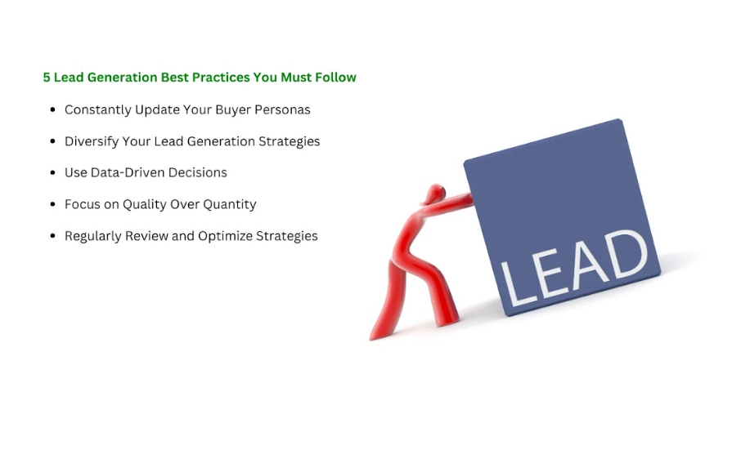
Here are 5 lead generation best practices that must be followed:

1. Constantly Update Your Buyer Personas
As part of the buyer persona development, it is crucial to collect feedback and new data periodically. This will make sure that your marketing effort does not become irrelevant in the middle of efforts to popularize it.

2. Diversify Your Lead Generation Strategies
Don’t rely on just one strategy, you can rely on different platforms and tactics like social media, SEO, and email marketing. Diversification helps dilute risks and promote a capability to reach the target market.

3. Use Data-Driven Decisions
To this, we add leverage analytics to strategies. This is also possible because data-oriented decisions yield better results in the process of lead generation.

4. Focus on Quality Over Quantity
Alternatively, it is better to focus on the quality of the leads that will most likely purchase the product. Consider repeat customers who are actively interested in your products and services.

5. Regularly Review and Optimize Strategies
No amount of lead generation should ever be accepted without scrutiny. Develop solutions in accordance with the data and results that illustrate the level of effectiveness in performance.

How Can You Measure and Optimize Your Lead Generation Efforts?
It must be understood that the effectiveness of lead generation can be effectively determined and improved constantly. Here is a procedure to assist you:

Process for Evaluating Lead Generation Effectiveness

- Assess Your Current Position: Identify the current or future status that you aim for in the field of lead generation campaigns.
- Analytics: Track measures such as conversion rate, the cost per lead, qualified leads can help you with a measure of accomplishment.
- Auditing: Old strategies must be reviewed periodically to determine which of them are effective and which are not.
- Adjust Strategies: When you want to adjust the strategy then use the findings of your audits for enhancing the lead generation process if it is necessary.

Importance of Regular Audits
Audits are crucial, as they allow checking your performance and making the right decisions on time.
These help you gain insights into the existing trends to determine whether there are problems or chances for improvement of business strategies.

What Are the Key Performance Indicators (KPIs) for Lead Generation?
It is very important to not only know but also follow KPIs because it is used to measure success.
Here is a list of typical KPIs that are vital in a safety program:

Conversion Rate:
This is the turnout that shows the likelihood of those individuals who showed interest in the company’s products and services and subsequently made purchases.

Cost per Lead:
Determines the cost required in order to attract a given lead.

Qualified Leads:
It measures the amount of leads that have fulfilled your qualification factors.

Lead Response Time:
It is used to evaluate the time taken to respond to leads.

Lead Source:
It entails the examination of the source of leads in order to establish which are most productive.

What Are Some Essential Lead Generation Tools?
To achieve the goal of lead generation successfully, it is highly recommended to use the following tools and platforms that ease the work:

CRM Systems:
There is strength in customer relations management and this involves following up on the customers.

Email Marketing Software:
Used to pass emails to prospects to cultivate their relationships.

Analytics Tools:
Track performance metrics and gain insights into your campaigns.

Which Lead Generation Company Should You Hire? (Three Angle Marketing)

There is no doubt that with reference to over-head services, Three Angle Marketing provides one of the best Lead Generation services in Dubai, UAE.

Our solutions are program-based and very accessible to suit your business. Our expertise includes:

Targeted Approach:
This leads to the formulation of targeted business lead-generation solutions that the organization requires.

Latest Technology:
We deplete the latest in technology and the best techniques so as to enhance our productivity.

Experienced Team:
The team working on this site is quite experienced and talented enough to provide a good level of service.
We understand very well that when working with a new customer, to underline that we have great experience in our field and can show a decent list of our successful projects.

Conclusion:
It should therefore be understood that lead generation is a deliberate and systematic process in management. If current difficulties are considered and these recommendations are integrated into sales lead practices in businesses in Dubai, UAE, there is an opportunity to significantly improve lead generation. At Three Angle Marketing, we will help you assist in every single step of the way. We have the required knowledge and the right tools which will assist in the attainment of your lead generation needs.

Get in touch with us today to find out more about how we can help you grow your list. Join our forces to reach new success in your business development.

For further details regarding lead generation transformation, you can contact Three Angle Marketing now. We are glad to introduce our team and offer you a working collaboration to achieve great results.

